

DEPARTMENT OF INFORMATION AND COMMUNICATION TECHNOLOGY
PRINCIPLES OF PROGRAMMING LOGIC AND DESIGN

Title : Designing logical solutions for sierra leone community challanges
Issue Date : Week 2
Due Date : Week 4
Lecturer/Examiner : Mr. Elijha fullal
Name of Student : Adiatu Jalloh
Student ID No. : 905006150
Class : BSEM 1101
Semester/Year : 1/1

Academic Honesty Policy Statement

I/We, hereby attest those contents of this attachment are my own work. Referenced works, articles, art, programs, papers or parts thereof are acknowledged at the end of this paper. This includes data excerpted from CD-ROMs, the Internet, other private networks, and other people’s disk of the computer system.

Student’s Signature: Date:
LECTURER’S COMMMENTS/GRADE:

for office use only upon receive
Remark

DATE :
TIME :
RECEIVER’S NAME :

TABLE OF CONTENTS

Contents
RATIONALE 3
PROBLEM DESCRIPTION 3
BACKGROUND 3
COMMUNITY IMPACT 3
BENEFICIARIES 3
PROPOSED SOLUTION 3
COMPUTATIONAL THINKING PROCESS 4
ALGORITHM DESIGN 4
OPEN SOURCE JUSTIFICATION 5
Benefits for Sierra Leone 5
Potential community contributions 5
DEGITAL PUBLIC GOODS JUSTIFICATION 5
ALGORITHM 5
PSEUDOCODE 6
FLOWCHART 7
FUNCTIONAL MODULES 9
EXPECTED OUTPUTS 9
GITHUB 10
CONCLUTION 11
REFRENCES 11

RATIONALE

PROBLEM DESCRIPTION

Poor waste management is a community problem that can affect people’s surroundings and public spaces.
In some communities, residents may not know where or how to report overflowing waste collection points. Waste may also remain unreported for a long time.

The proposed project is a community waste collection and reporting system that allows residents to report waste problems and enabled responsible waste-management personnel to organize and respond to those reports.

BACKGROUND
Waste management requires cooperation between community members and waste-management authorities. A simple digital system can provide a structured way for residents to submit information such as:
- Location of the waste
- Type of waste problem
- Description of the problem
- Date of the report
- Reporter information
The system can then process the information and assign an appropriate status to the report.

COMMUNITY IMPACT
The system could help:
- Residents report waste problems more easily.
- Waste-management workers identify reported locations
- Authorities organize waste-collection activities.
- Communities keep better records of waste problems.
- Problems receive attention in a more organize way.

BENEFICIARIES
The main beneficiaries would include:
- Community residents
- Waste-management workers
- Local authorities
- Community leaders
- Environmental organizations

PROPOSED SOLUTION
The proposed solution is a community waste collection and reporting system. The basic process will be:
Resident → submit report → system checks information → report stored → waste team reviews → action taken → status updated.

The system will have three main types of actions:
- Submit a report
- Review reports
- Update report status

COMPUTATIONAL THINKING PROCESS
- Problem Decomposition
The large problem is divided into smaller problems:
- Collect resident information.
- Collect waste-location information.
- Record the waste problem.
- Check whether the information is complete.
- Store the report.
- Update its status.

- Pattern recognition
Similar waste reports can be identified. For example:
- Overflowing bins
- Illegal dumping
- Uncollected waste
- Blocked waste collection areas

- Abstraction
The system does not need every detail about the resident. It mainly needs information necessary to process the report, such as:
- Name or identifier
- Location
- Waste problem
- Description
- Date

- Algorithmic thinking
The system follows a sequence of logical steps:
Receive information → validate → store → review → take action → update status.

ALGORITHM DESIGN
The algorithm will follow these steps:
- Start the system.
- Display the main menu.
- Allow the user to choose an option.
- If the user chooses report waste problem, collect the required information.
- Check whether all required information has been approved.
- If information is missing, ask the user to enter it again.
- If the information is complete, save the report.
- Assign the report a status of pending.
- Allow an authorized user to view reports.
- The authorized user selects a report.
- Update the report status.
- Continue processing reports while there reports available.
- End the system.

The project can support:
SDG11-Sustainable cities and communities
The system can contribute to cleaner and more organized communities by helping residents report waste-management problems.
It can also relate to:
SDG12-Responsible consumption and production
Better waste reporting and collection can support more responsible waste management.

OPEN SOURCE JUSTIFICATION
The proposed system can be developed as open source software.
This means the source code and project materials can be made available under an appropriate open-source licence so that developers and communities can study, improve and contribute to the project.

Benefits for Sierra Leone
Open-source development can:
- Encourage local developers to contribute.
- Reduce dependence expensive proprietary software.
- Allow the system to be adapted to different communities.
- Encourage students to learn from the project.
- Support collaboration between developers.

Potential community contributions
Community members and developers could contribute by:
- Reporting bugs.
- Suggesting improvements.
- Improving the interface.
- Adding useful features.
- Translating the system into local languages.

DEGITAL PUBLIC GOODS JUSTIFICATION
The system could become a digital public goods (DPG) if it is developed and shared in a way that provides public benefit and follows appropriate openness and responsible- use principles.
It could promote:
- Accessibility
- Openness
- Community participation
- Public benefit
- Reusability
For example, the system could be adapted for different communities in Sierra Leone instead of being limited to one location.

ALGORITHM
Algorithm: community waste reporting system
Step 1: start.
Step 2: display the main menu.
Step 3: ask the user to select an option.
Step 4: if the user selects “report waste problem”:
- Enter location
- Enter type of waste problem
- Enter description
- Enter date
Step 5: check whether all required information has been answered.
Step 6: if information is incomplete, display an error message and request the missing information.
Step 7: if information is complete, save the report.
Step 8: set report status to pending.
Step 9: display confirmation to the user.
Step 10: allow the waste-management officer to view reports.
Step 11: select a report for processing.
Step 12: update it status to:
- Pending
- In process
- Resolved
Step 13: repeat until all selected reports have been processed.
Step 14: end.

PSEUDOCODE
BEGIN
DISPLAY “community waste collection and reporting system”

REPEAT
DESPLAY “1. Report waste problem”
DISPLAT “2. View report”
DISPLAY ”3. Update report”
DISPLAY “4. Exit”

INPUT CHOICE
IF choice = 1 THEN
INPUT location
INPUT waste type
INPUT description
INPUT date

IF location is empty OR Waste Type is empty
OR description is empty THEN
DISPLAY “please provide all required information.”
ELSE
SAVE report
SET status = “pending”
DISPLAY “waste report submitted successfully.”
END IF
ELSE IF choice = 2 THEN
DISPLAY all available reports
ELSE IF choice = 3 THEN
INPUT report ID
IF report exists THEN
INPUT new status
UPDATE report status
DISPLAY “report updated successfully.”
ELSE
DISPLAY “report not found.”
END IF
ELSE IF choice = 4 THEN
DISPLAY “thank you for using the system.”
ELSE
DISPLAY “invalid option.”
END IF
UNTIL choice = 4
END

FLOWCHART
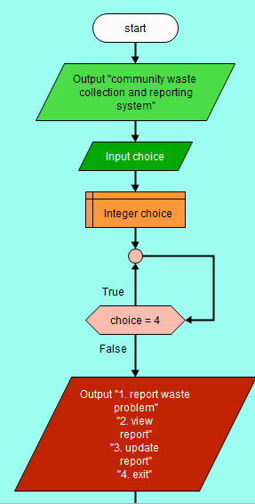
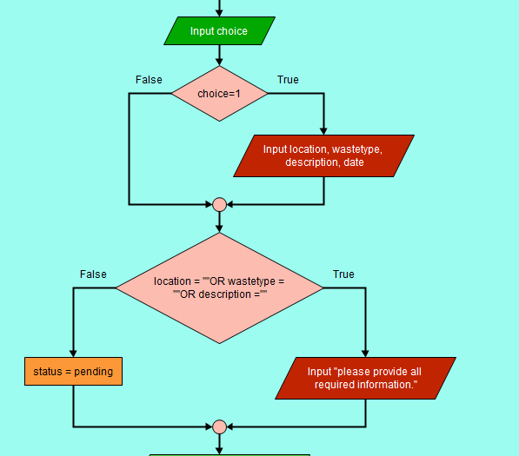

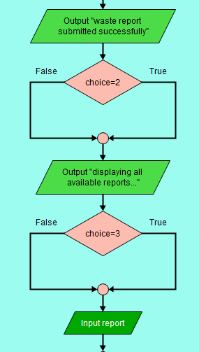
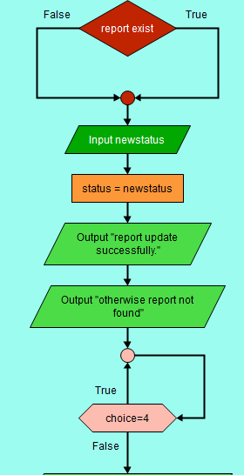

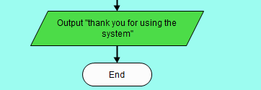

FUNCTIONAL MODULES
The system can be divided into the following modules.

Module 1: submit report
Responsible for receiving a waste report from a resident.
Inputs:
- Location
- Waste type
- Description
- Date
Module 2: validate report
Checks whether the required information has been provided.
Input: report information
Output:
- Valid
- Invalid
Module 3: save report. Stores a valid waste report.
Input: valid report
Output: saved report.
Module 4: view report. Allows authorized users to view submitted reports.
Input: stored reports
Output: list of reports
Module 5: update report status. Changes the status of the report.
Possible statuses: pending → in progress → resolved

EXPECTED OUTPUTS

Scenario 1: success report
Input:
Location: jui
Waste type: overflowing bin
Description: waste has not been collected.
Output:
“waste report submitted successfully.”
Status: pending

Scenario 2: missing information
Input:
Location: jui
Waste type: empty
Description: waste problem
Output:
“please provide all required information.”

Scenario 3: report updated
Input:
Report ID: 001
New status: in progress
Output:
“report updated successfully.”

Scenario 4: report resolved
Input:
Report ID: 001
New status: resolved
Output:
“report updated successfully.”

GITHUB

CONCLUTION
The community waste collection and reporting system provides a simple digital solution for reporting and managing waste problems in communities. The system applies computational thinking , algorithms, pseudocode, flowcharts, selection, repetition, and functional modules. It can help improve communication between resident sand waste-management teams. The project also supports SDG 11: sustainable cities and communities and could be developed as an open source Digital Public Good for wider community use.

REFRENCES
- United Nations. (N.D).Sustainable Development Goles: Goal 11- Sustainable Cities And Communities.
- Flowgorithm. (N.D.). Flowgorithm – Flow Chart Programming
- GitHub. (N.D.).GitHub Documentation.
- Limkokwing University Of Creative Technology – Sierra Leone. Prog101; Principles Of Programming Logic And Design Assignment Brief

